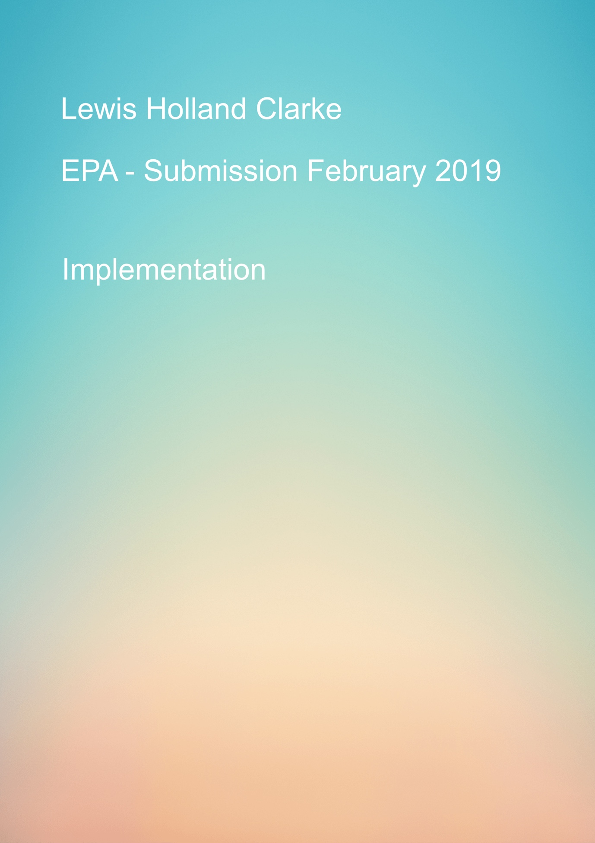

Table of Contents

Deployment 2

Future Development 2

Product owner retrospective 2

The aim of this initial sprint was to provide the client with an MVP of useable features for the music player.

We believe that the first sprint has provided this but has also highlighted areas through development and testing that could be vastly improved upon.

## Deployment

Currently the application is fully working in the Dev test environment and can de access by opening a terminal and navigating to the “Music Player EPA” file and running the command “node Server” this will start the server on a localhost3000.

Navigate to this using a web browser and the app will accessible for testing.

Also, a production pipeline has been set up using the Heroku service and a working app will be loaded into <https://music-player-epa.herokuapp.com/> and updates to the source code will be pushed into the production version at the above URL.

## Future Development

Progress bar

One of the first areas that would be added to the backlog would be to introduce a progression bar to the music controls with included timer, to the user can progress the song to a specific time point.

Adding songs to playlist

After much testing and previous development, the direction we initially when with the adding songs path may not have been the most user friendly, during future sprints the code would be refactored to allow the user to add songs in a more natural manner, such as including a plus and minus button to allow the user to add and remove songs from playlists.

Side navigation

In future sprints the side navigation would be refactored and incorporated into the main page of the application to allow for quicker transactions with the GUI.

## Product owner retrospective

It is at this point in the sprint where we would invite the product owner to a demo of the live MVP, after the demo and bugs that had been found and any improvements or amendments to the application would be documented and added to the back log for further sprints.